### ****MEDICAL INVENTORY MANAGEMENT****

**College Name: A.V.P College of arts and science**

**College Code: bruaj**

TEAM ID: NM2025TMID25427

TEAM MEMBERS: 4

**Team LeaderName: SABARNA. S**

**Email: sabarnasenthil03@gmail.com**

**Team Member: BHUVANESWARI. M**

**Email: bhuvaneswarimoorthi46@gmail.com**

**Team Member: RAKSHITHA. K**

**Email: rakshithakannan2@gmail.com**

**Team Member: MOUNISHA DEVI.M**

**Email: mounishadevimuthuraj@gmail.com**

**1.INTRODUCTION**

1.1Project Overview :

This project is a comprehensive Salesforce application to streamline and manage various operational aspects of medical inventory. The system aims to efficiently maintain supplier details, manage purchase orders, track product details and transactions, and monitor the expiry dates of products. Maintain detailed records of suppliers, including contact information. Catalog product information, including descriptions, stock levels. Monitor and track product expiry dates to avoid using expired items. Comprehensive reports to track supplier performance, and purchase orders.

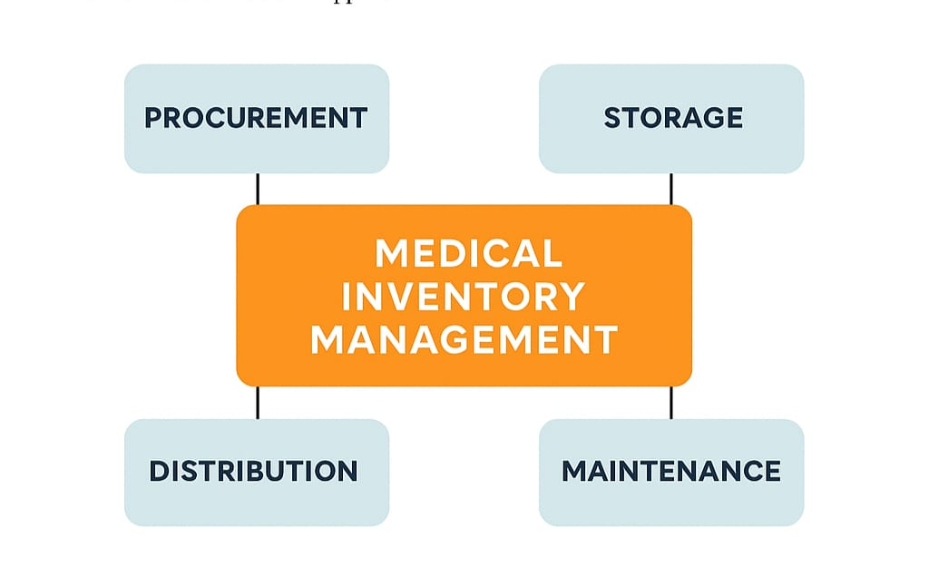

1.2Purpose

Maintain accurate and up-to-date supplier details, including contact information.

Manage and track purchase orders effectively.

Organize product information such as descriptions and stock levels.

DEVELOPMENT PHASE

**Creating Developer Account:**

**By using URL -** <https://www.salesforce.com/form/developer-signup/?d=pb>



* Create a product object: product, Purchase Order, Order Item, Inventory Create Transaction and Supplier objects.

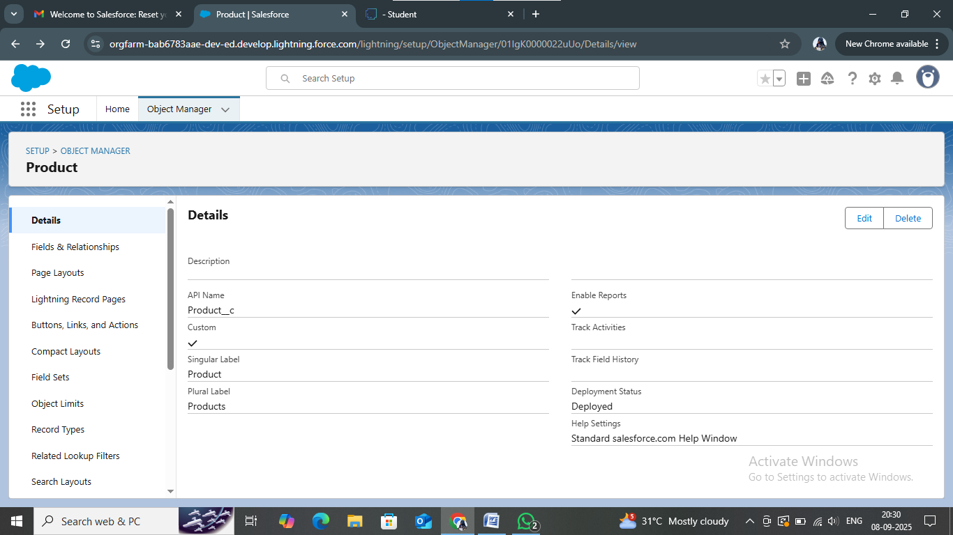

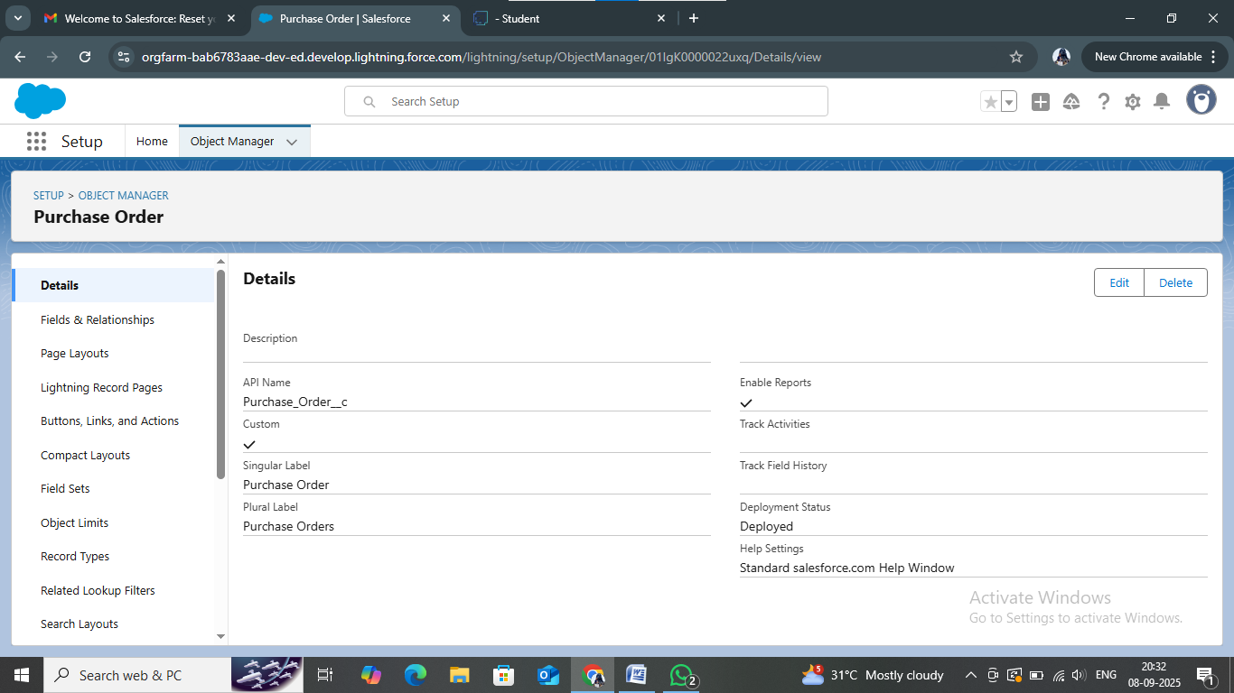

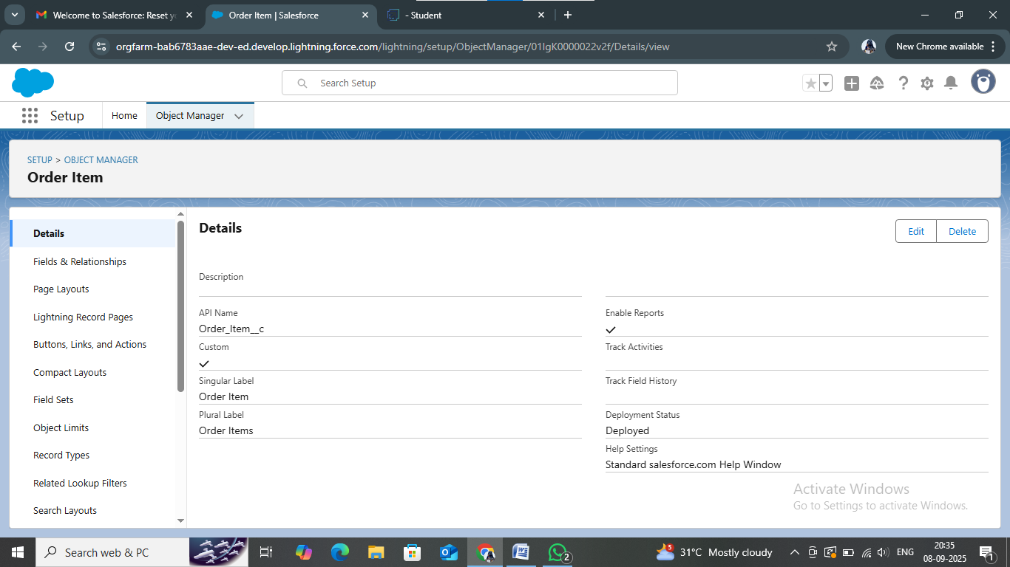

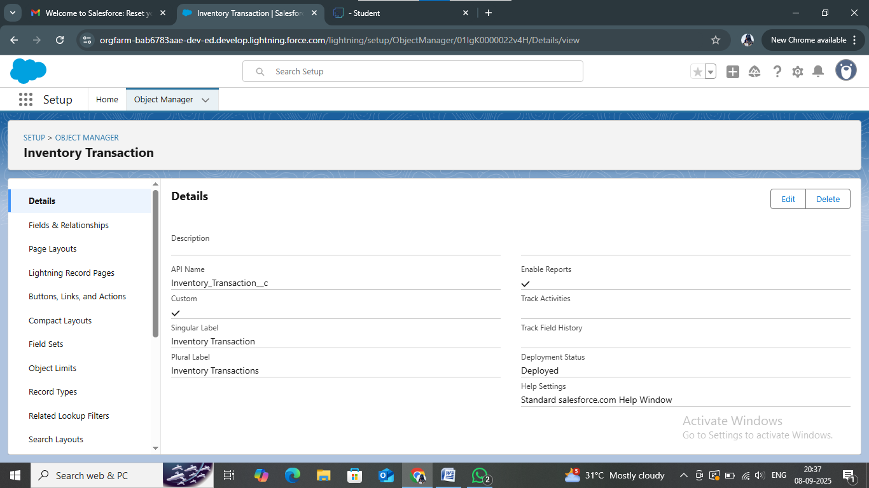

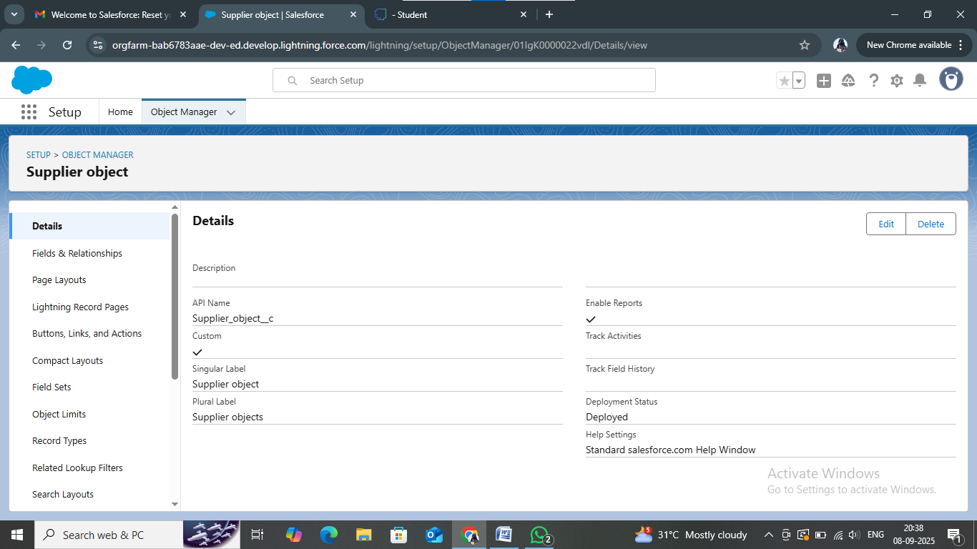

Creating a tab for Product Object: Create the Tabs for the remaining Objects, they are “Product, Purchase Order, Order Item, Inventory Transaction, Supplier”

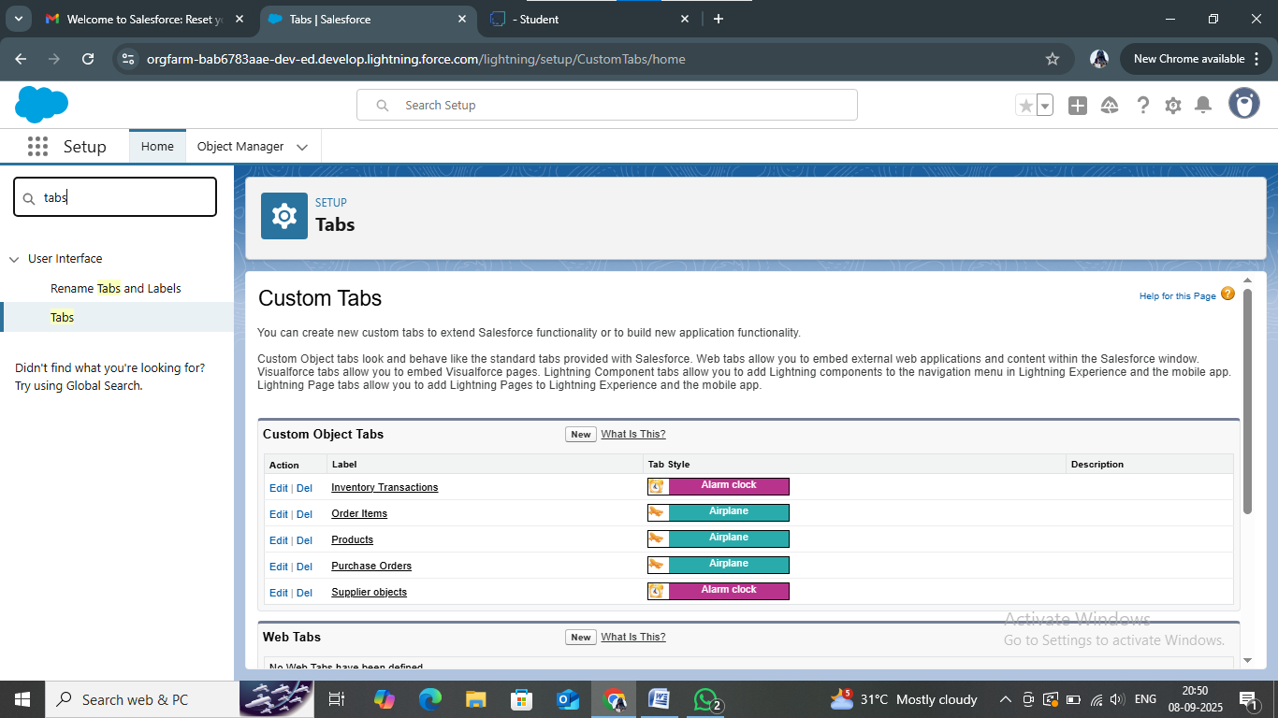

* Developed Lightning App With relevant tabs

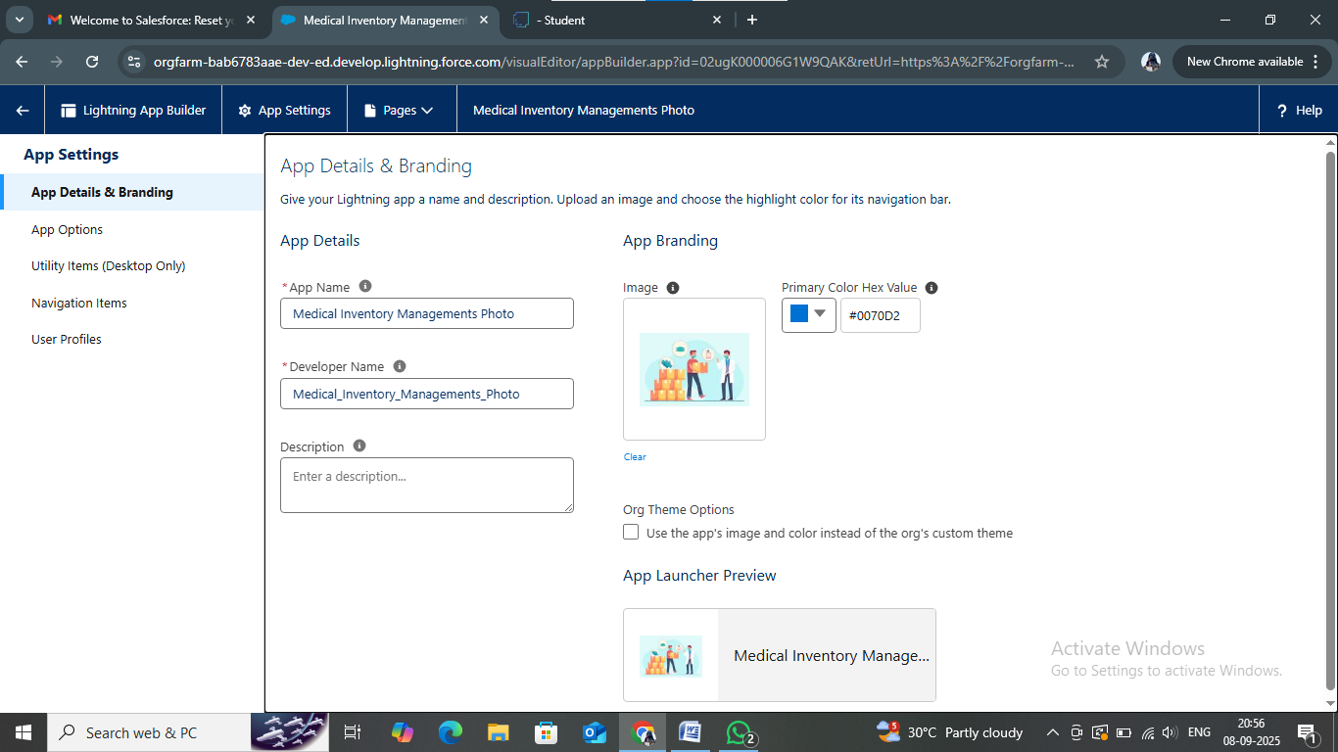

* Create Fields: Object, Fields Name, Data Type

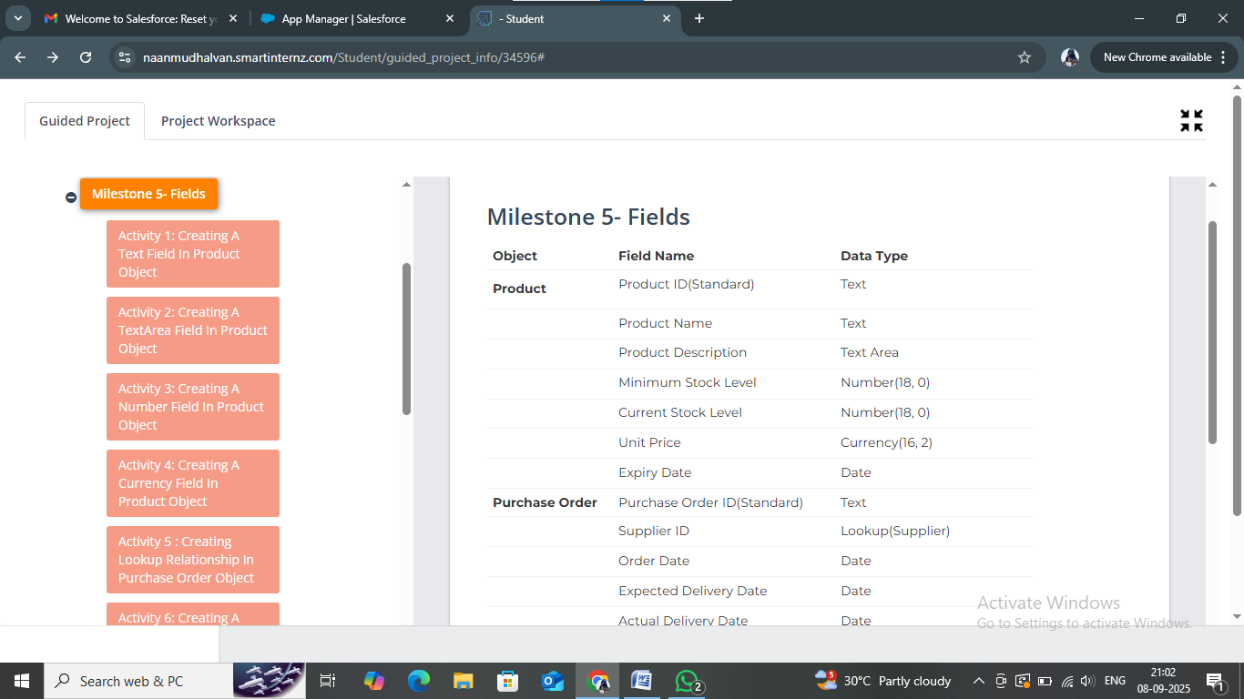

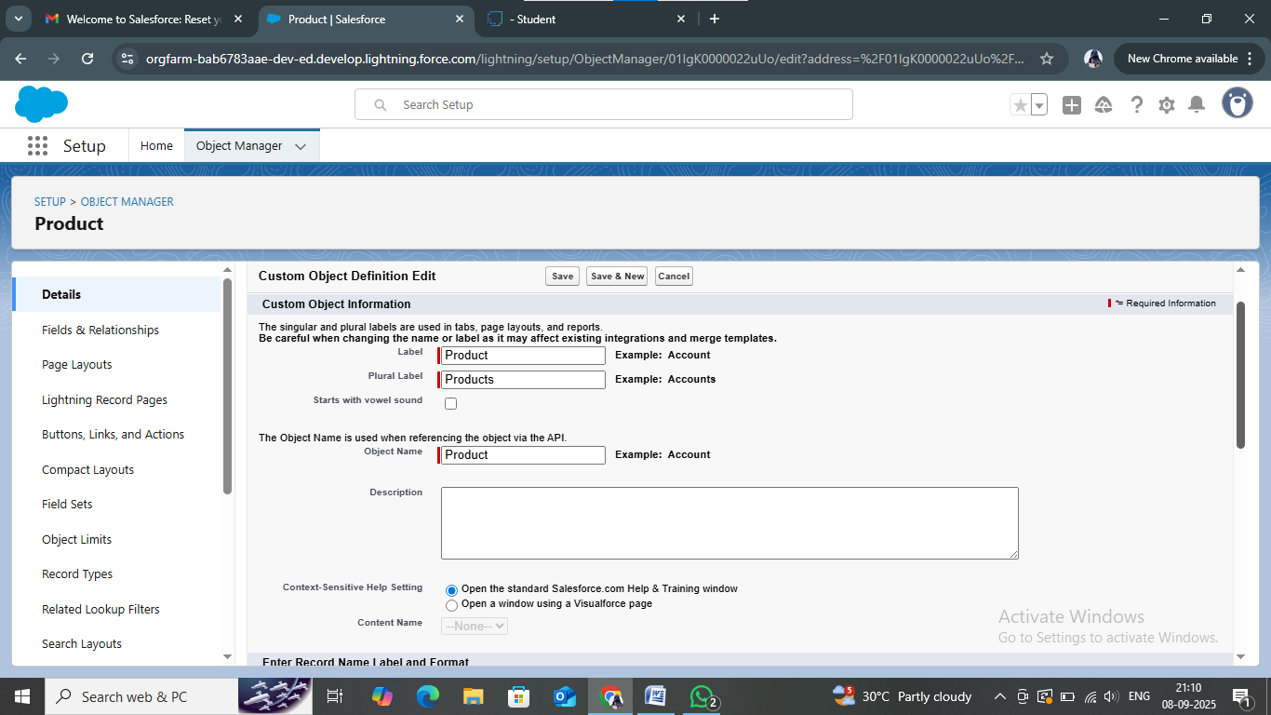

* To edit a page layout: Product Object, Purchase Order, Order Item, Inventory Transaction and Supplier objects.

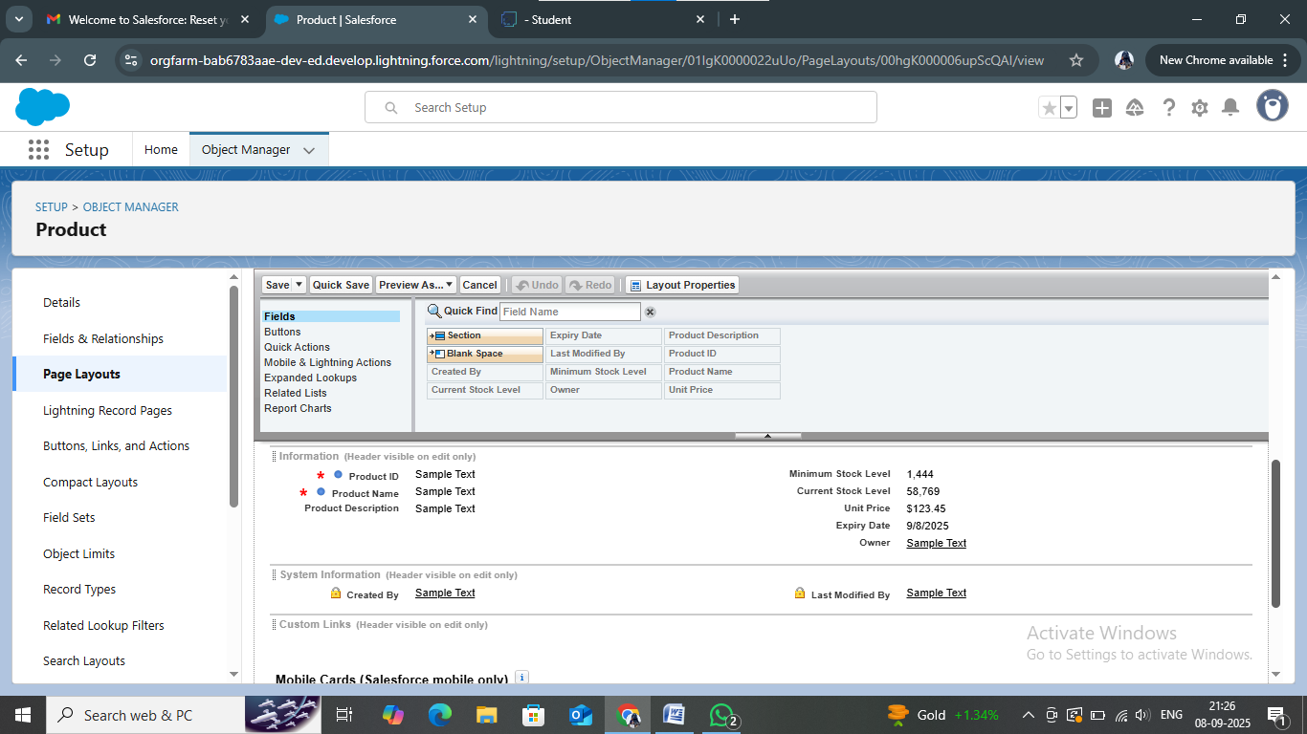

* To create a compact layouts: product orders, purchase order object.

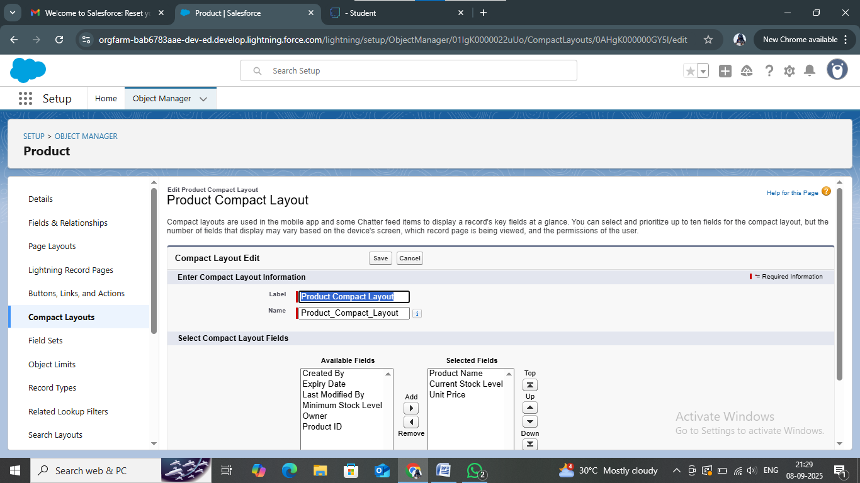

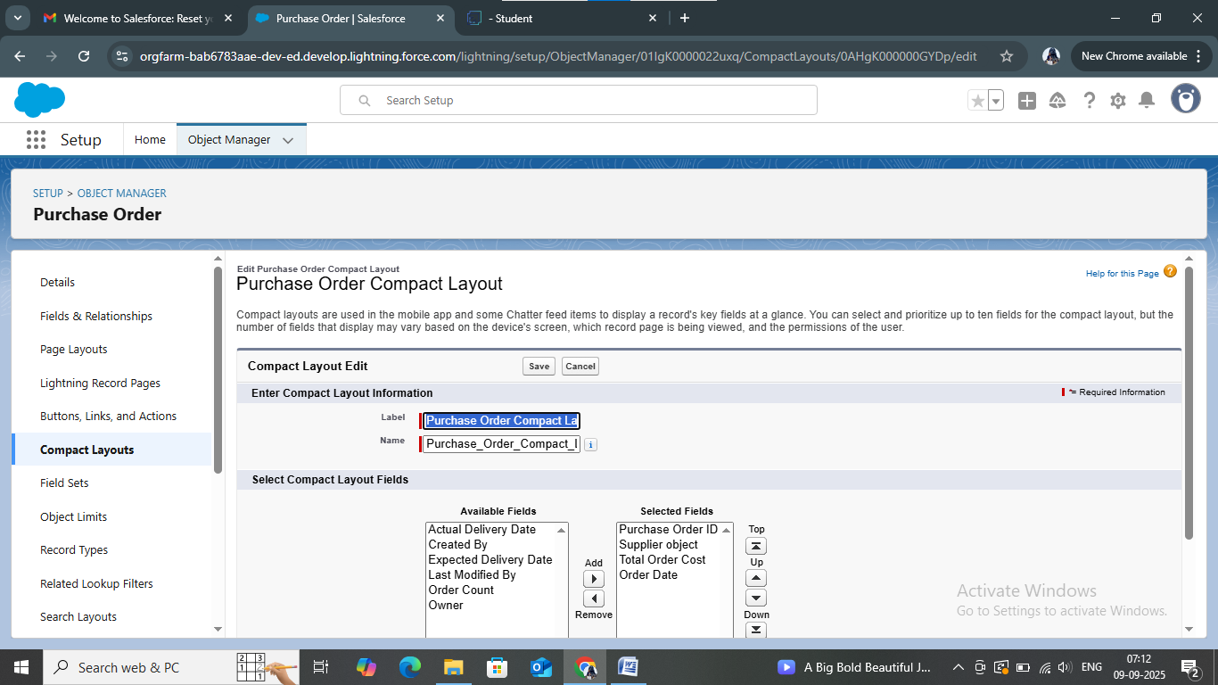

* create an Expected Delivery Date Validation rule:

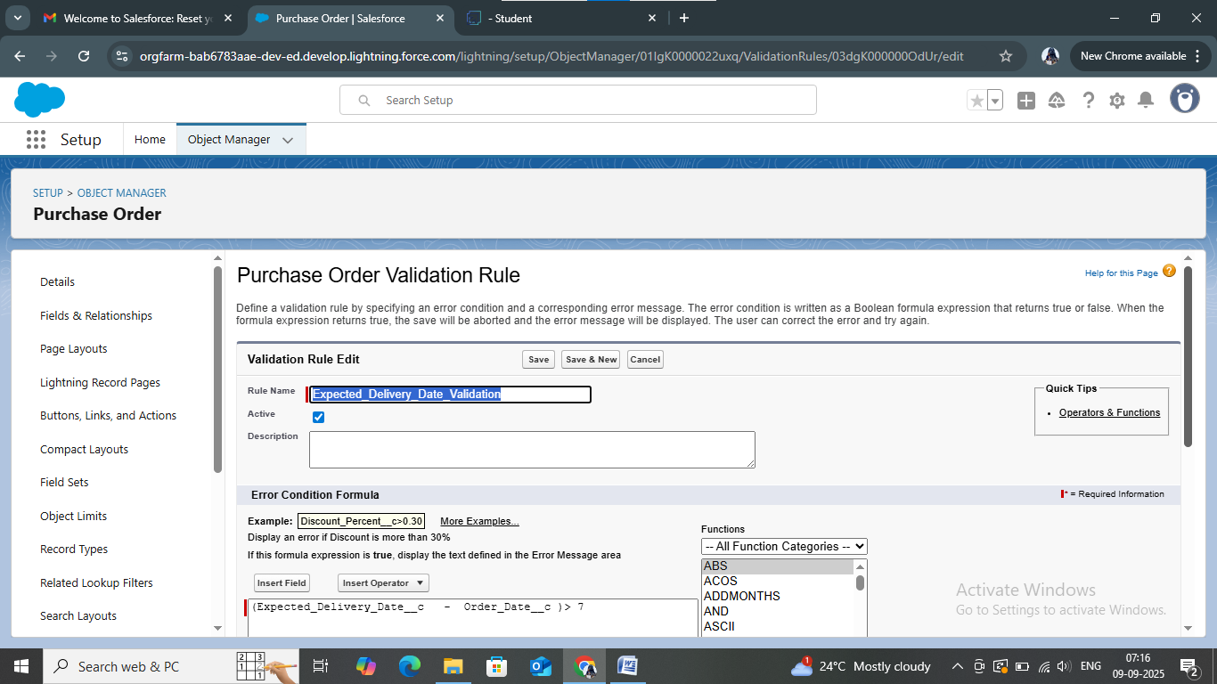

* create an Inventory Manager Profile: Medical Inventory Management, Purchase Manager

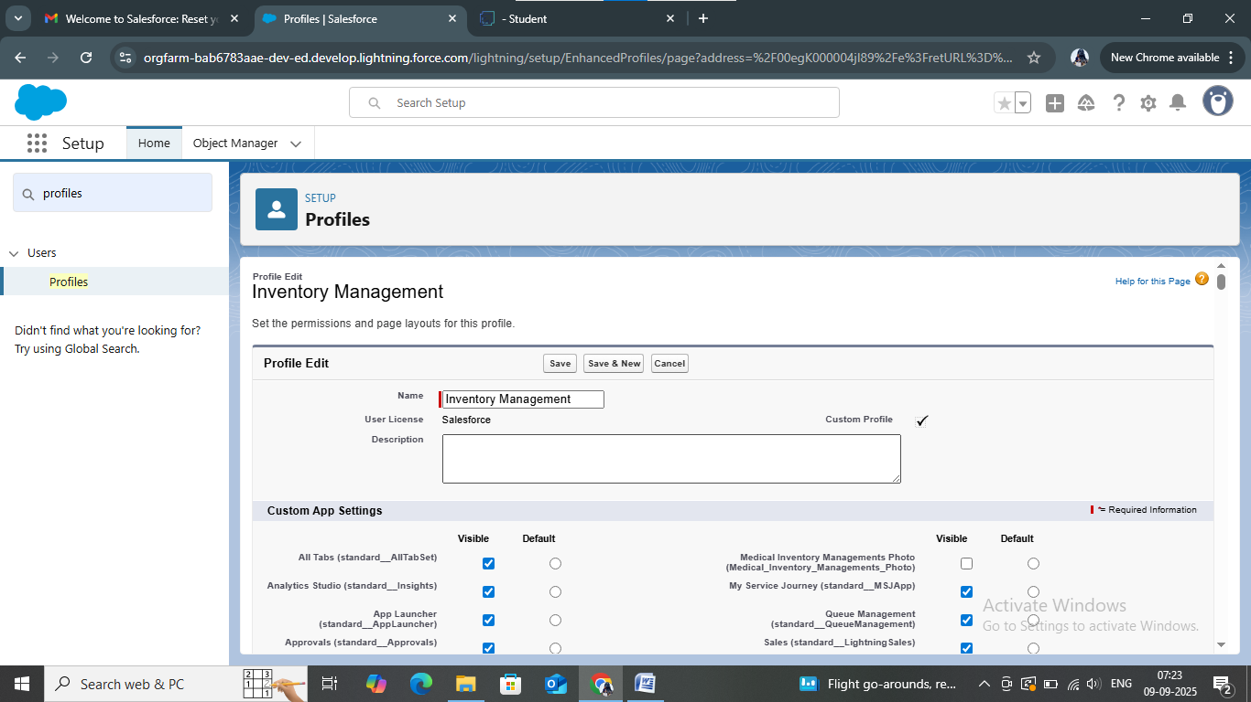

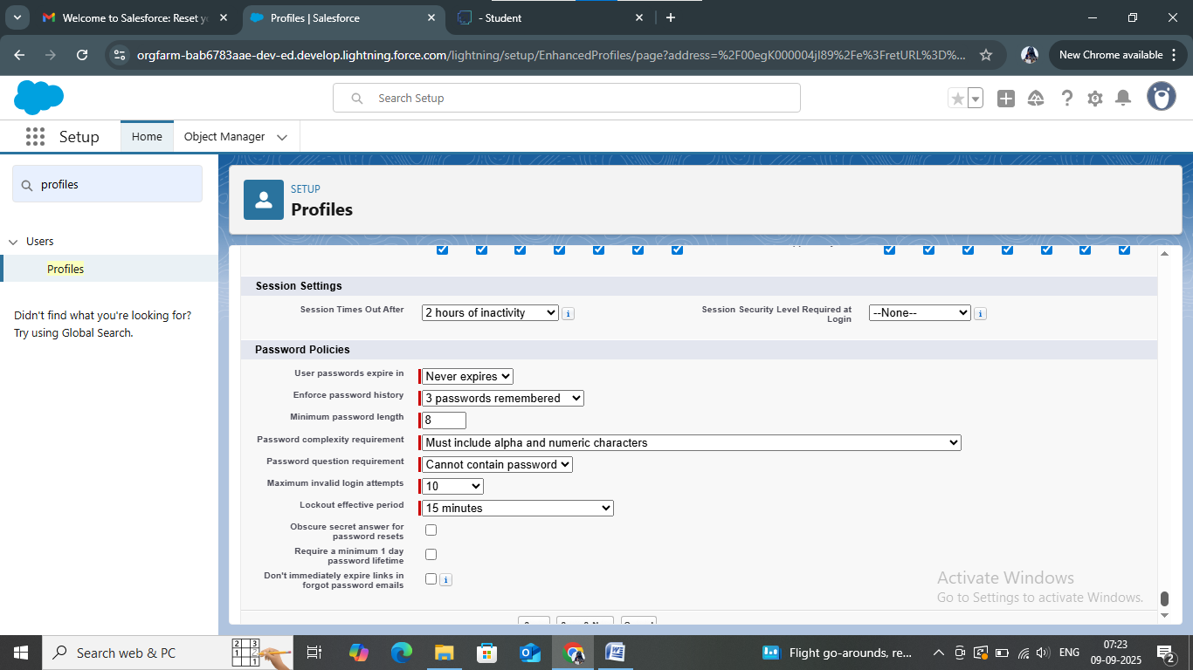

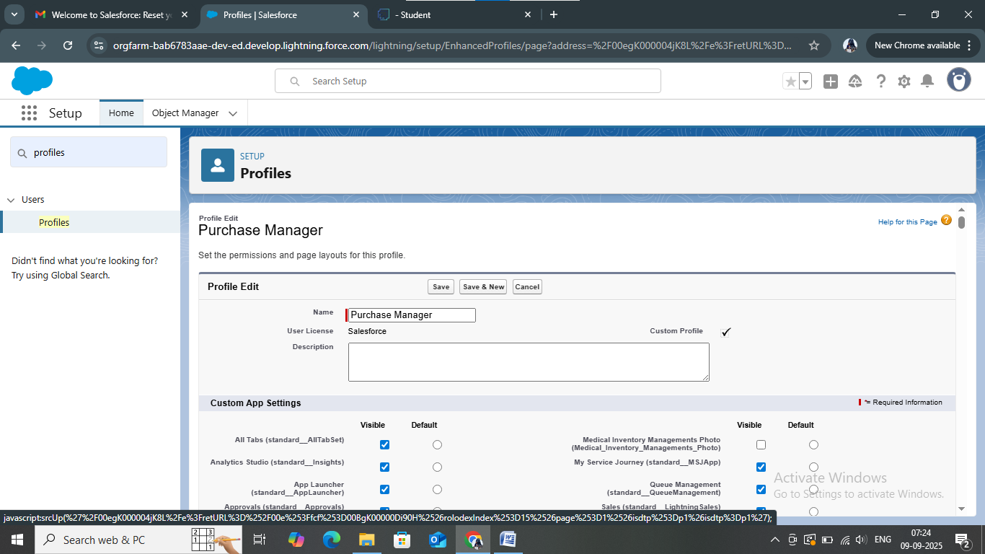

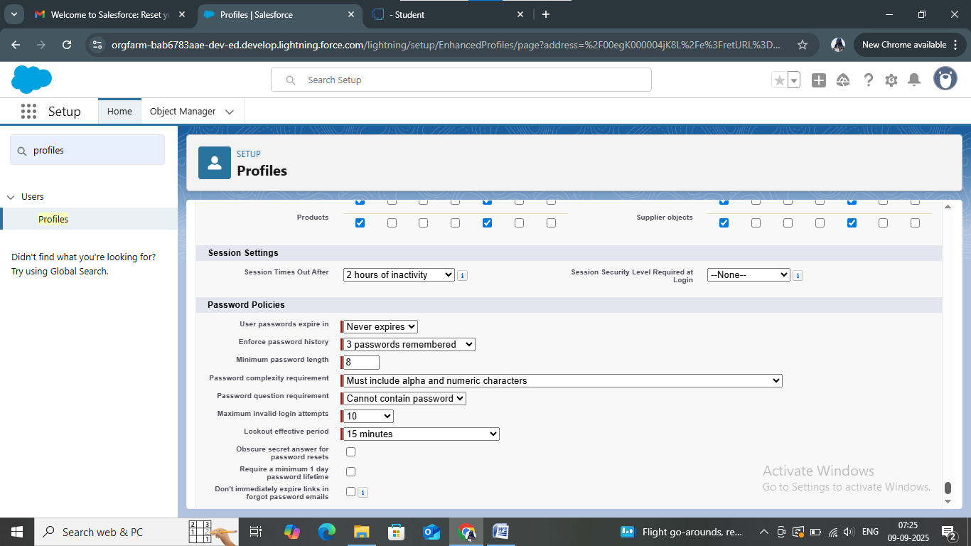

* Create a Purchasing Manager Role

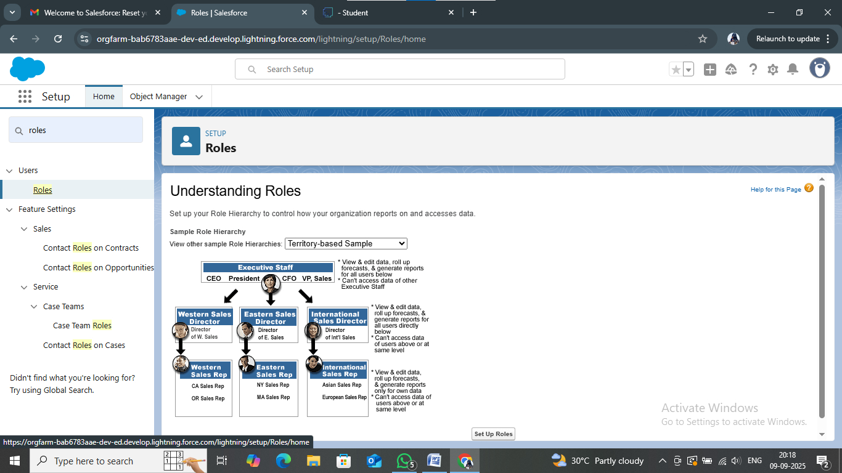

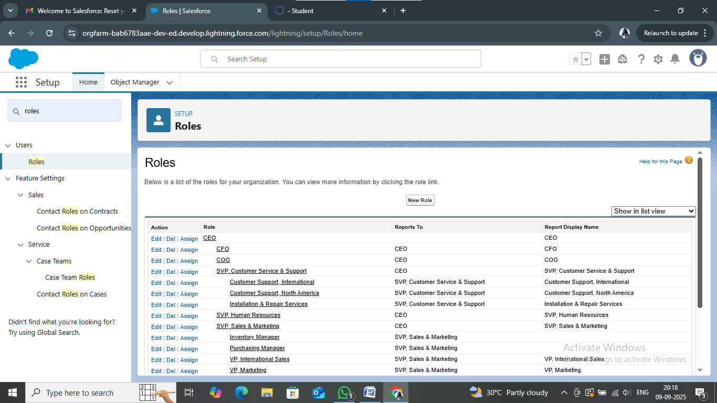

* Create a Permission Set

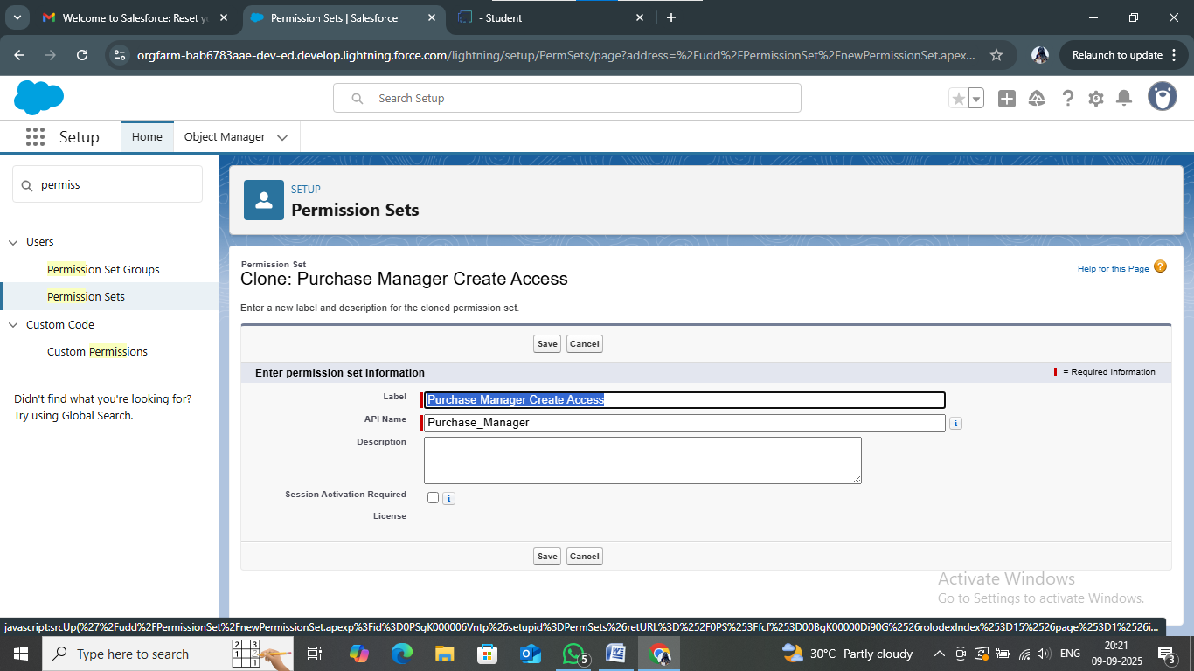

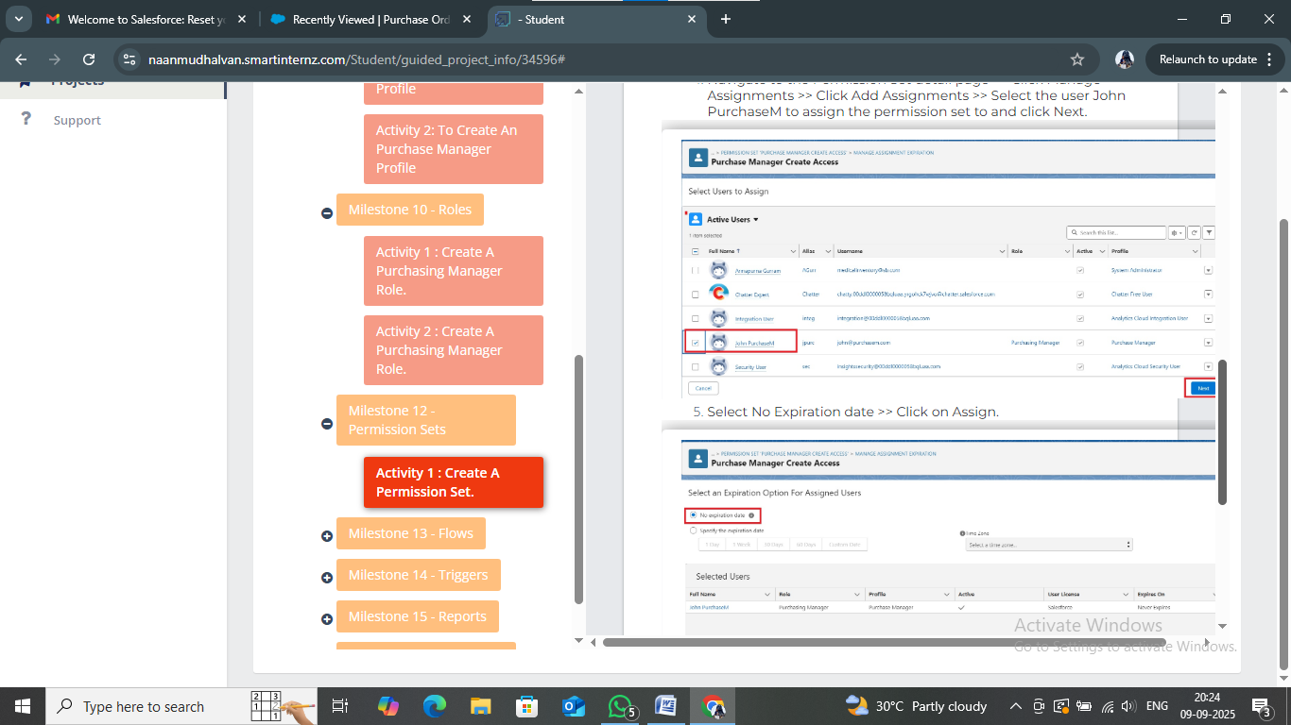

* Create Flow to update the Actual Delivery Date

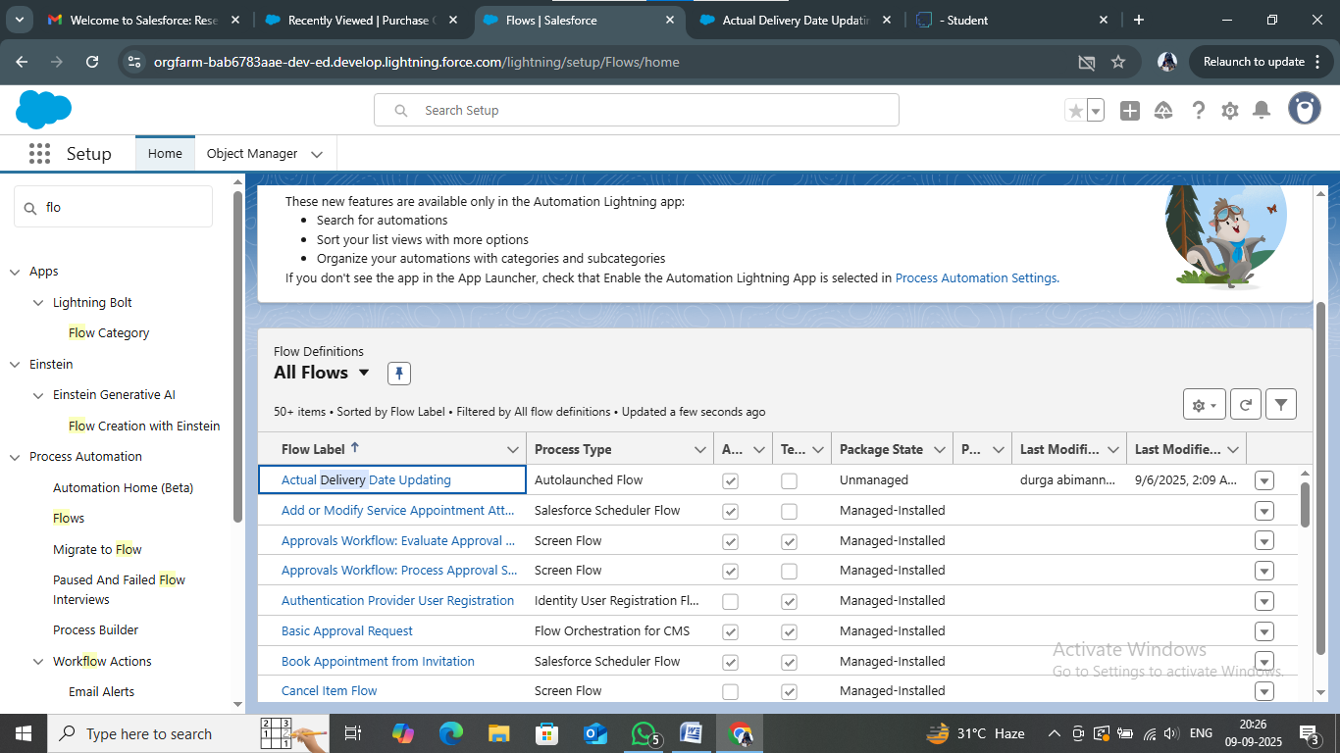

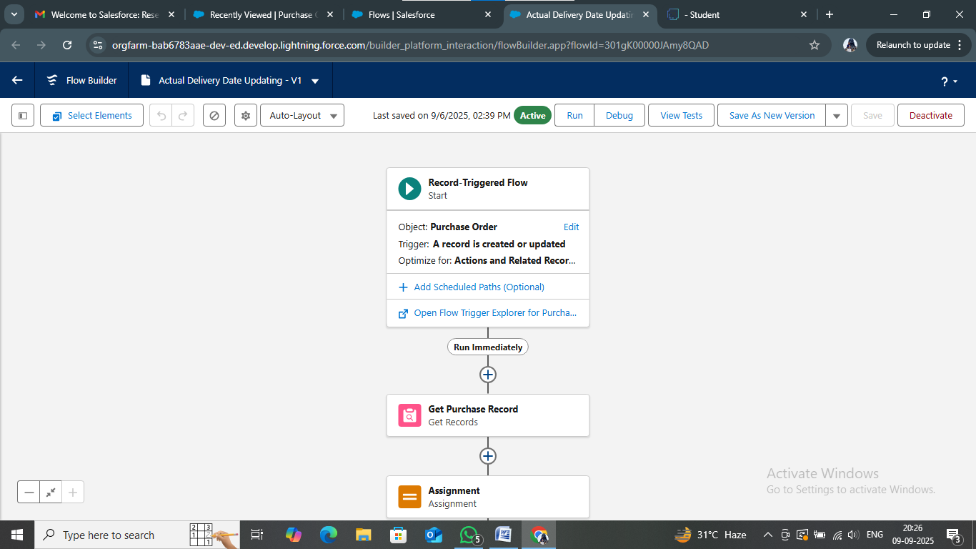

* Create a Trigger to Calculate total amount on Order Item

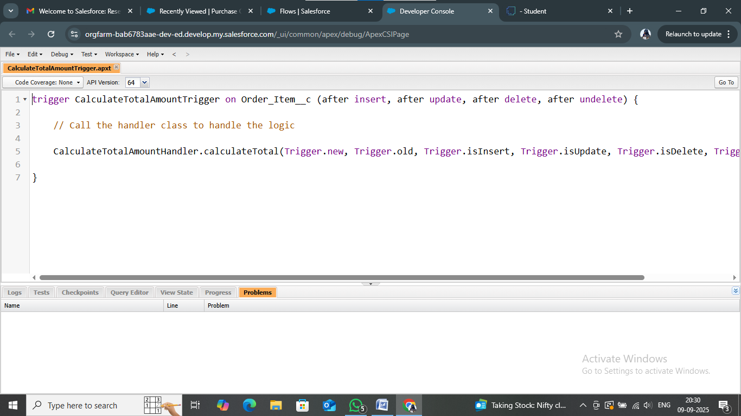

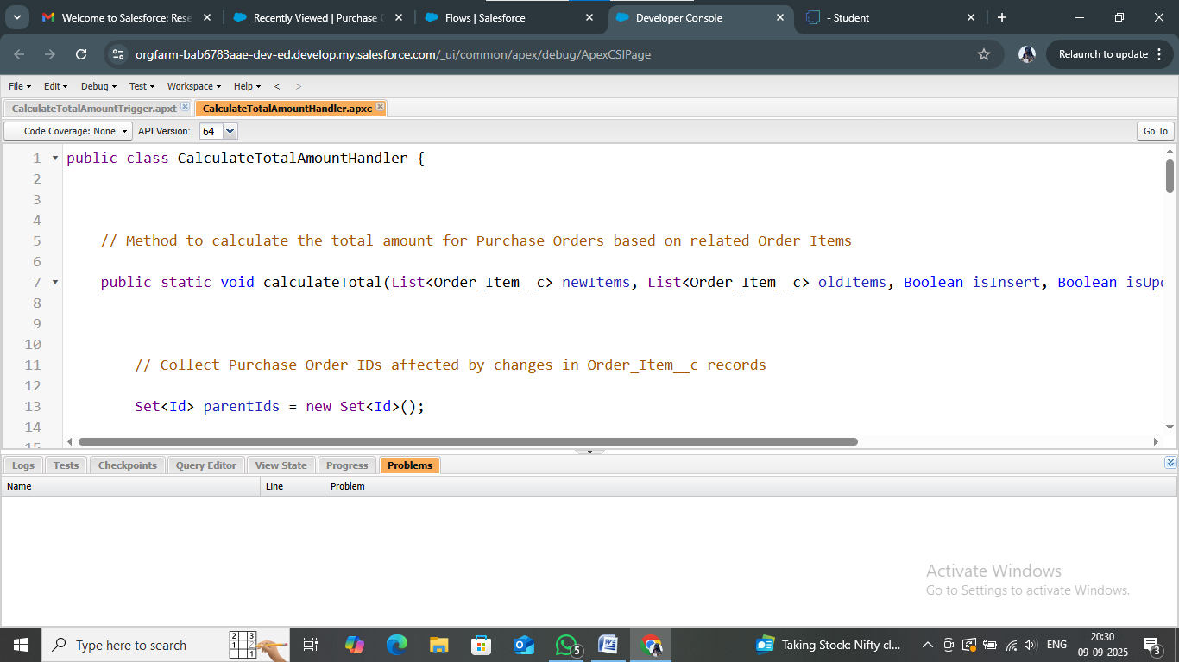

* Create a Purchase Orders based on Suppliers, Complete Purchase Details Report

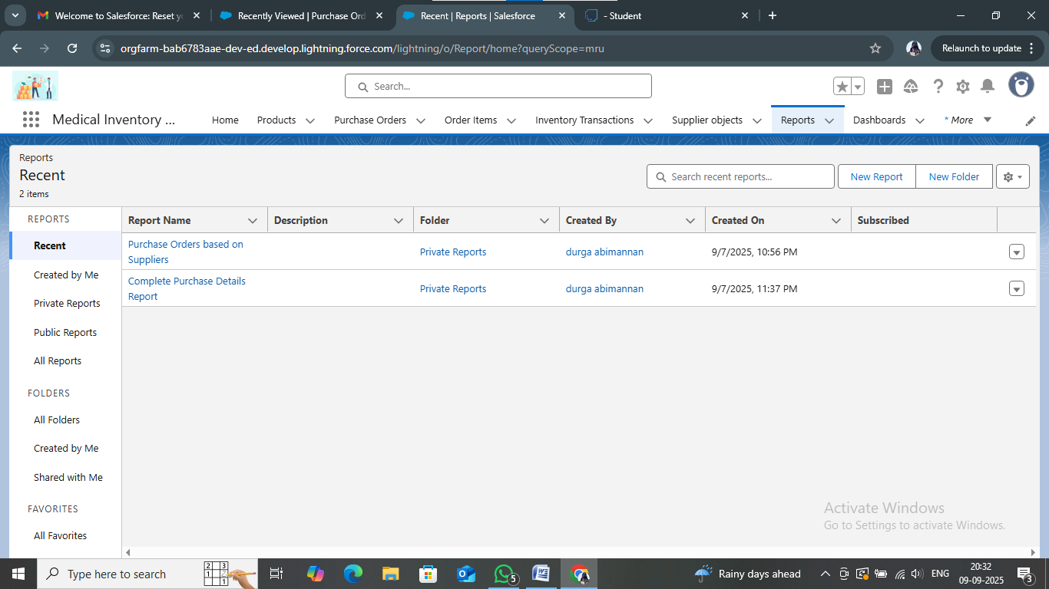

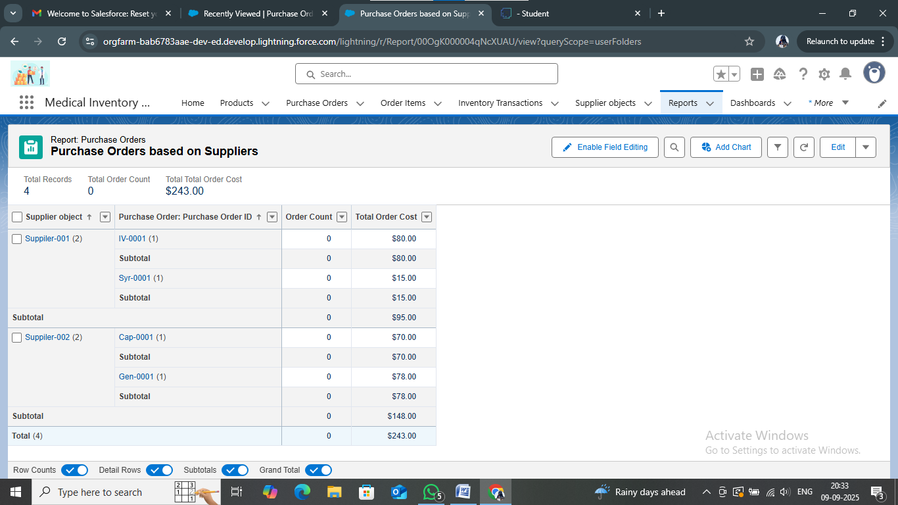

* Create Dashboard: Purchase Orders based on Suppliers

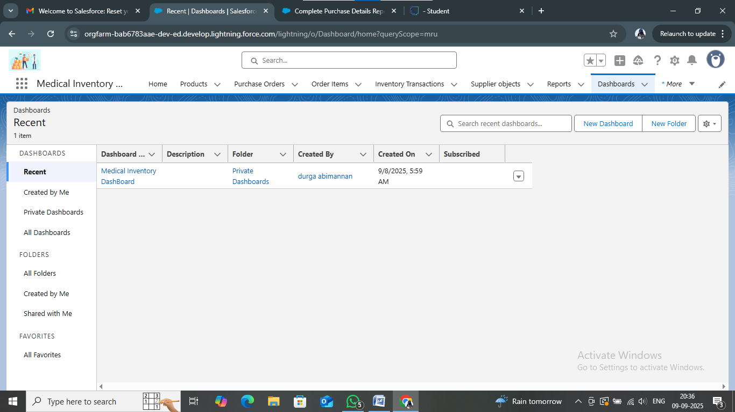

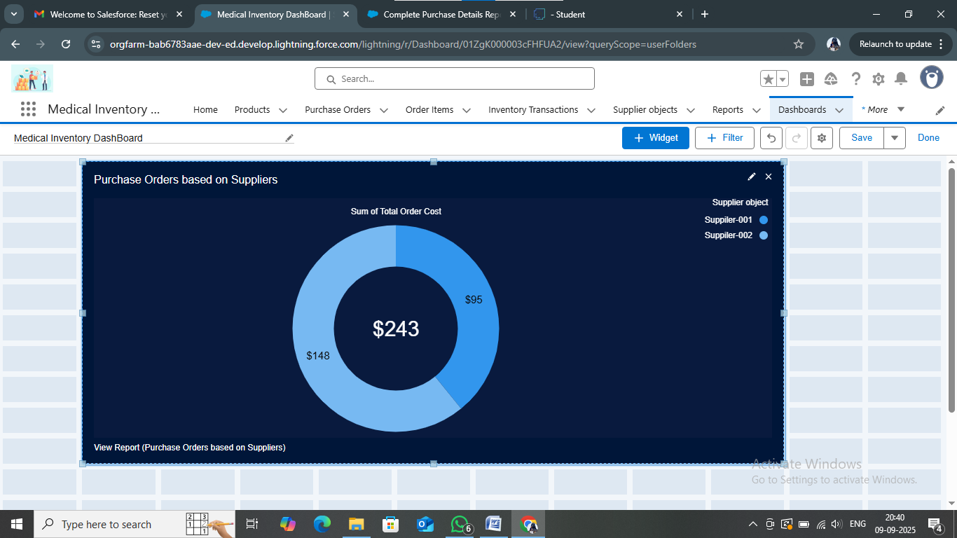

Conclusion: The Medical Inventory Management System successfully streamlines the process of maintaining supplier details, managing purchase orders, tracking product stock, and monitoring expiry dates. By automating these tasks, the system minimizes errors, reduces wastage, and ensures timely availability of essential medical supplies. The project not only enhances operational efficiency but also supports better decision-making through accurate reporting and analysis. Overall, this solution provides a reliable, user-friendly, and cost-effective way to manage medical inventories, ensuring improved healthcare service delivery.